Publish your app to the Microsoft Teams store

# Steps:

1. [Review the Teams store validation guidelines](https://docs.microsoft.com/en-us/microsoftteams/platform/concepts/deploy-and-publish/appsource/prepare/teams-store-validation-guidelines) to ensure your app meets Teams .app and store standards.
2. [Create a Partner Center developer account](https://docs.microsoft.com/en-us/microsoftteams/platform/concepts/deploy-and-publish/appsource/prepare/create-partner-center-dev-account).
3. [Prepare your store submission](https://docs.microsoft.com/en-us/microsoftteams/platform/concepts/deploy-and-publish/appsource/prepare/submission-checklist), which includes running automated tests, compiling test notes, and creating a store listing, among other important tasks to help expedite the review process.
4. [Submit your app](https://docs.microsoft.com/en-us/office/dev/store/add-in-submission-guide) through Partner Center.
5. If your submission fails, work with Microsoft directly to [resolve the issues and resubmit your app](https://docs.microsoft.com/en-us/microsoftteams/platform/concepts/deploy-and-publish/appsource/resolve-submission-issues).

# Tips for rapid approval to publish your app:

## During design phase

Review the [store validation guidelines](https://docs.microsoft.com/en-us/microsoftteams/platform/concepts/deploy-and-publish/appsource/prepare/teams-store-validation-guidelines) early in your app's life cycle (design phase) to ensure that you build your app in alignment with the store requirements. If you build your app in line with these guidelines, then it will prevent any rework due to non-adherence to store policies.

## Prior to app submission

* + [Create your Partner Center account](https://docs.microsoft.com/en-us/microsoftteams/platform/concepts/deploy-and-publish/appsource/prepare/create-partner-center-dev-account) well in advance. If you run into any challenges with your [Partner Center account](https://docs.microsoft.com/en-us/microsoftteams/platform/concepts/deploy-and-publish/appsource/prepare/create-partner-center-dev-account), create a [support ticket](https://docs.microsoft.com/en-us/azure/marketplace/partner-center-portal/support).
  + Review the [store validation guidelines](https://docs.microsoft.com/en-us/microsoftteams/platform/concepts/deploy-and-publish/appsource/prepare/teams-store-validation-guidelines) again to ensure that your app is in alignment with the store requirements. Review helps reduce the number of issues observed in your app and so, the time taken to approve your app.
  + Test and re-test your app:
    - Validate your app package using the Teams [Developer Portal](https://dev.teams.microsoft.com/home) to identify and fix any package errors.  
      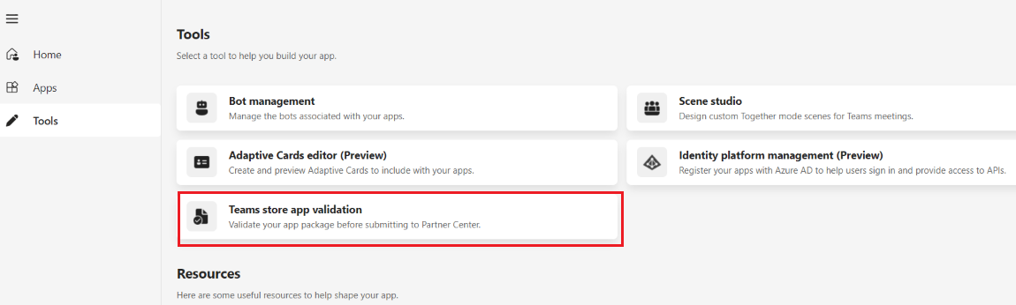
    - Self-test your app thoroughly prior to app submission to ensure it adheres to store policies. Sideload the app in Teams and test the end-to-end user flows for your app. Ensure the functionality works as expected, links aren't broken, user experience isn't blocked, and any limitations are clearly highlighted.
    - Test your app across desktop, web, and mobile clients. Ensure that the app is responsive across different form factors.
  + Complete [publisher verification](https://docs.microsoft.com/en-us/azure/active-directory/develop/publisher-verification-overview) before you submit your app. If you run into any issues, you can create a [support ticket](https://docs.microsoft.com/en-us/azure/marketplace/partner-center-portal/support) for resolution.
  + As you prepare for app submission, [follow the checklist](https://docs.microsoft.com/en-us/microsoftteams/platform/concepts/deploy-and-publish/appsource/prepare/submission-checklist) and include the following details as part of your submission package:
    - Thoroughly verified app package.
    - Working admin and non-admin user credentials to test your app functionality (if your app offers a premium subscription model).
    - Test instructions detailing app functionality and supported scenarios.
    - Setup instructions if your app requires more configuration to access app functionality. Alternately, if your app requires complex configuration, you can also provide a [provisioned demo tenant](https://docs.microsoft.com/en-us/office/developer-program/microsoft-365-developer-program-get-started) with admin access so that our validators can skip the configuration steps.
    - Link to a demo video that demonstrates key user flow for your app. This is highly recommended.

## Post app submission

* + After you’ve reviewed the validation report, reply to the email thread with any queries related to the validation report, or if you need any extra support to resolve the reported issues.
  + Ensure that you've adequate developer bandwidth to resolve any reported issues until the app is approved.
  + Ensure that you've [resolved all issues](https://docs.microsoft.com/en-us/microsoftteams/platform/concepts/deploy-and-publish/appsource/resolve-submission-issues) reported to you by the concierge service teamsubm@microsoft.com before sharing your app package for further testing. It helps reduce the number of iterations required to validate your app and so, the time taken to approve your app.
  + Avoid changing app functionality during the validation process that might lead to the discovery of new issues and increase the time it takes to approve your app.

# **Microsoft Teams store validation guidelines**

*Mandatory Fix*

# App name

This section is in line with Microsoft [commercial certification policy number 1140.1.1](https://docs.microsoft.com/en-us/legal/marketplace/certification-policies#114011-app-name) and provides additional guidance to developers on naming their apps.

An app's name plays a critical role in how users discover it in the store. Use the following guidelines to name an app:

* The name must include terms relevant to your users.
* Names of core Teams features must not be included in your app name, such as:
  + Chat
  + Contacts
  + Calendar
  + Calls
  + Files
  + Activity
  + Apps
  + Help
* Prefix or suffix common nouns with the developer's name. For example, Contoso Tasks instead of Tasks.
* Must not use Teams or other Microsoft product names such as Excel, PowerPoint, Word, OneDrive, SharePoint, OneNote, Azure, Surface, Xbox, and so on, that could falsely indicate co-branding or co-selling. For more information about referencing Microsoft software products and services, see [Microsoft Trademark and Brand Guidelines](https://www.microsoft.com/legal/intellectualproperty/trademarks/usage/general).
* If your app is part of an official partnership with Microsoft, the name of your app must come first. For example, Contoso Connector for Microsoft Teams.
* Must not copy the name of an app listed in the store or other offer in the commercial marketplace.
* Must not contain profane or derogatory terms. The name also must not include racially or culturally insensitive language.
* Must be unique. If your app (Contoso) is listed in the Microsoft Teams store and Microsoft AppSource and you want to list another app specific to a geography, such as Contoso Mexico, your submission must meet the following criteria:
  + Call out the app's region-specific functionality in the title, metadata, first response app experience, and help sections. For example, title must be Contoso Mexico. App title must clearly differentiate an existing app from the same developer to avoid end-user confusion.
  + When uploading the app package in Partner Center, select the right Markets where the app will be available in the Availability section.

Tip

Your app’s branding on the Microsoft Teams store and Microsoft AppSource including your app name, developer name, app icon, Microsoft AppSource screenshots, video, short description and website either separately or taken together must not impersonate an official Microsoft offering unless your app is an official Microsoft 1P offering.

# Suitable for workplace consumption

# This section is inline with Microsoft commercial certification policy number [1140.1.2](https://docs.microsoft.com/en-us/legal/marketplace/certification-policies#114012-workplace-appropriateness), [100.8](https://docs.microsoft.com/en-us/legal/marketplace/certification-policies#1008-significant-value), and [100.10](https://docs.microsoft.com/en-us/legal/marketplace/certification-policies#10010-inappropriate-content) and provides additional guidance to developers on building workplace appropriate apps.

App content must be suitable for general workplace consumption and follow all restrictions listed in the commercial marketplace certification policies. Content related to religion, politics, gambling, and prolonged entertainment is prohibited.

Your app must enable group collaboration, improve an individual's productivity, or both. Apps intended for team bonding and socializing must be collaborative and designed for multiple participants. The apps must not require a substantial time investment of over 60 mins per session or affect productivity.

# Similar platforms and services

# This section is inline with [Microsoft commercial certification policy number 1140.1.3](https://docs.microsoft.com/en-us/legal/marketplace/certification-policies#114013-other-platforms-and-services).

Apps must focus on the Teams experience and not include the names, icons, or imagery of other similar chat-based collaboration platforms or services within the app content or in the app’s metadata unless the app provides specific interoperability.

# Authentication

This section is inline with [Microsoft commercial certification policy number 1140.1.4](https://docs.microsoft.com/en-us/legal/marketplace/certification-policies#114014-access-to-services) and provides guidance to developers on authenticating their apps with external services.

For more information on how to implement app authentication, see [authentication in Teams](https://docs.microsoft.com/en-us/microsoftteams/platform/concepts/authentication/authentication).

#### **Authenticating with external services**

If your app authenticates users with an external service, follow these guidelines:

* Sign in, sign out, and sign up experiences:
  + Apps that depend on external accounts or services must provide clear and simple sign in, sign out, and sign up experience.
  + When users sign out, they must sign out only from the app and remain signed in to Teams.
  + Apps that depend on external accounts or services must provide a way forward for new users to sign up or contact the app publisher to learn more about the services and get access to the services. Way forward must be available in the app’s manifest, AppSource long description, and app first run experience (bot welcome message, tab setup or config page).
  + Apps that require tenant admin to complete one time setup must call out dependency on tenant admin to configure the app (before any other tenant user can install and use the app).  
    Dependency must be called out in the app’s manifest, AppSource long description, all first run experience touchpoints (bot welcome message, tab setup or config page), help text as considered necessary as part of bot response, compose extension, or static tab content.
* Content sharing experiences: Apps that require authentication with an external service to share content in Teams channels must clearly state in the help documentation (or similar resources) on how to disconnect or unshare content if that feature is supported on the external service. This doesn't mean the ability to unshare content must be present in your Teams app.

# Bots

This section is inline with [Microsoft commercial marketplace policy number 1140.3.2](https://docs.microsoft.com/en-us/legal/marketplace/certification-policies#114032-bots-and-messaging-extension).

For apps that use the Microsoft Azure Bot Service (such as bots and message extensions), you must follow all requirements defined in the Microsoft [Online Services Terms](https://www.microsoftvolumelicensing.com/DocumentSearch.aspx?Mode=3&DocumentTypeId=46).

Bots must always ask permission to upload a file and display a confirmation message.

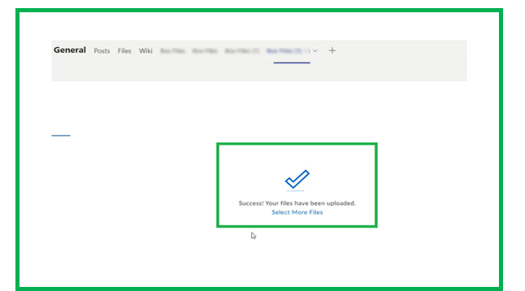

# External domains

This section is in line with [Microsoft commercial marketplace policy number 1140.3.3](https://docs.microsoft.com/en-us/legal/marketplace/certification-policies#114033-external-domains) and provides developer guidance on the usage of restricted domains in the validDomains manifest property.

Don't include domains outside of your organization's control (including wildcards) and tunneling services in your app's domain configurations. The following exceptions include:

* If your app uses the Azure Bot Service's OAuthCard, you must include token.botframework.com as a valid domain, or the Sign-in button won't work.
* If your app relies on SharePoint, you can include the associated root SharePoint site as a valid domain using the {teamSiteDomain} context property.

# Compatibility

Apps must be fully functional on the latest versions of the following operating systems and browsers:

* Microsoft Windows
* macOS
* Microsoft Edge
* Google Chrome
* iOS
* Android

Your app must show a graceful failure message on unsupported browsers and operating systems.

# Response time

Teams' apps must respond within a reasonable timeframe or show a loading or typing indicator or message or warning.

* Tabs must respond within two seconds or display a loading message or warning.
* **Bots must respond to user commands within two seconds or display a typing indicator.**
* Message extensions must respond to user commands within two seconds.
* Notifications must display within two seconds of the user action.

# App icons

Icons are one of the main elements people see when browsing the Teams store.

Your icons must communicate your app's brand and purpose while adhering to the following requirements:

* Your app package must include two .png versions of your app icon: A color icon and an outline icon.
* The color version of your icon must be 192x192 pixels. Your icon symbol can be any color or colors, but it must sit on a solid or fully transparent square background.
* The outline version of your icon is displayed in the following scenarios:
  + When your app is in use and hosted on the app bar on the left side of Teams.
  + When a user pins your app's message extension.
* The outline must be 32x32 pixels and can be white with a transparent background or transparent with a white background. The icon must not have any extra padding around the symbol.
* Your app package must include correctly sized and formatted icons. The icons must match the information in store listing metadata.

For more information, see [icon guidelines](https://docs.microsoft.com/en-us/microsoftteams/platform/concepts/build-and-test/apps-package#app-icons).

# Privacy policy

The privacy policy can be specific to your Teams app or an overall policy for all your services.

* If you use a generic privacy policy template, you must add a reference to services, applications, or platforms in the scope of your privacy policy. You don’t need to specify your Teams app in the scope, if you include a reference to services, applications and platforms. The app validation process will interpret these references to include your Teams app along with your other services or websites.
* Must include how you handle user data storage, retention, and deletion. You must describe the security controls for data protection.
* Must include your contact information.
* Must not include URLs that are broken or for beta or staging purposes.
* Must not include links to AppSource.
* Must not require authentication to access privacy policy.
* Must not include any commerce UI or store links.

# Terms of use

Use the following guidelines to write the Terms of use:

* Must be specific and applicable to your offering.
* Must be hosted on your own domain.
* Must have a secure (HTTPS) link.
* Access to Terms of use must not require authentication.

# 